High schools face challenges reviewing student documentation for Ready Graduate, CCR, and TISA, especially at year-end and during the summer.

* To streamline this process, three new reports are available in PowerSchool:
  + PowerSchool > Data and Reporting > Reports > Custom CMCSS Reports > High School Reports > Grad Reports > (Ready Grad, CCR Grad, TISA Grad).
* These reports track student progress for each pathway and associated measures year-round.
* Schools should audit student status, focusing on fourth-year students and early graduates, at a minimum in December, February, and April each year.
* At year-end, confirm and correct the status of graduating students and email [assessment@cmcss.net](mailto:assessment@cmcss.net) by the first Friday in May to confirm completion.
  + When appeals require additional documentation, the school will be emailed based on the data included in the three reports.
* The Accountability and Assessment Team is available to support you with any questions you have ([assessment@cmcss.net](mailto:assessment@cmcss.net)).

**Processes for Documentation Appeals**

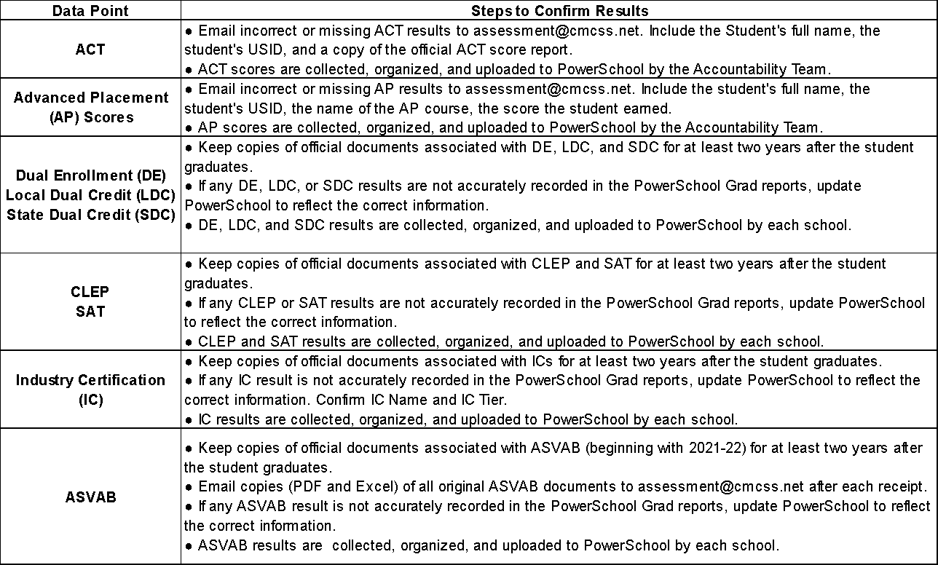

Left to update:

* Full team review and edits.
* Get Leslie’s input, counselor view.
* Once finalized, post to web and video for reports.