- Prior to beginning your 2022-2023 ePlan school plan you will want to have a copy of your most currently level director approved school level action plan, your most currently approved 2022-2023 Title I budget, and any ESSER funding (i.e., MS RTI Coaches) utilized within your school. You will be asked to upload your action plan and budget into ePlan. As changes are made to either of these documents the updated copy should be uploaded into ePlan.
- Additionally, you will want to confirm you have access to Orion and your school’s plan. Directions to complete this check can be found here.
- Go to https://orion.tneducation.net/launcher and log in.  - Username: first.last@tneducation.net  - If you are having difficulty with your Orion/SSO please see: https://accountability.cmcss.net/sso/  - NOTE: Only the building principal’s login will access a school plan | 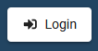  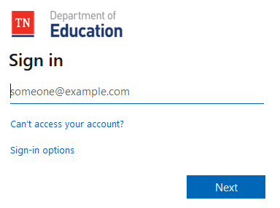
- Select ePlan. | 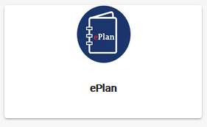
- On the left side, hover over Planning. Then, slide over and select Planning Tool. | 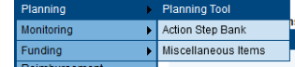
- Select School Plan. | 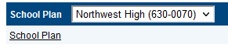
- If prompted, click Sign In with TDOE Single Sign-on.
- Open your 2022-2023 School Plan  - Below your school’s name, you will see the school year listed in the Planning for dropdown.  - The status of your plan is in the top right.  - You will see green check marks next to some tabs showing they are completed. Please note, these are not completed. Most of your plan has been entered but there are still elements you must address. | 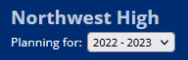  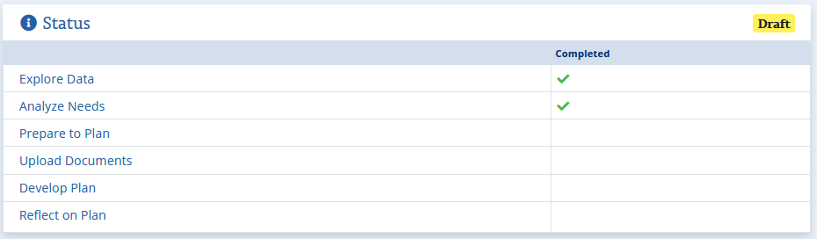
- Open and read the content in all tabs to familiarize yourself with what has already been entered into your plan by the Accountability Team. | 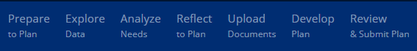
- All schools:  - Open ‘Prepare to Plan’  - Follow the directions to complete the ‘Identify Team’ at the top of the page.  - Follow the directions to complete ‘Stakeholder Involvement’ at the top of the page.  - There is district information already included in the stakeholder involvement section, but each school should add their own school information at the bottom of this section.  - You may review your entries for identify team and stakeholder involvement in last year’s plan as a guide if needed.  - The next three sections are Goals established, Goals met, and Goals partially met. The district has completed these sections. Schools should add any appropriate school level information at the bottom of each of these three sections. | 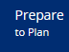  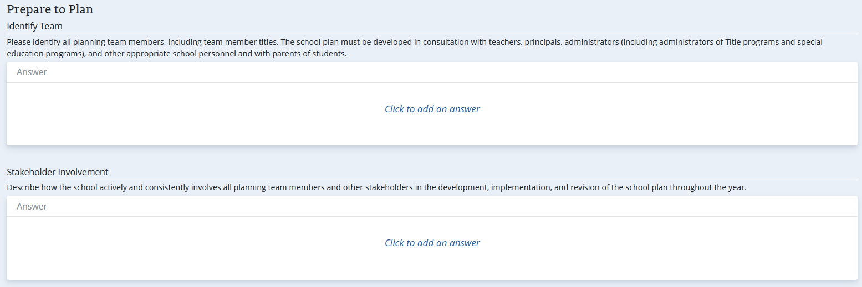  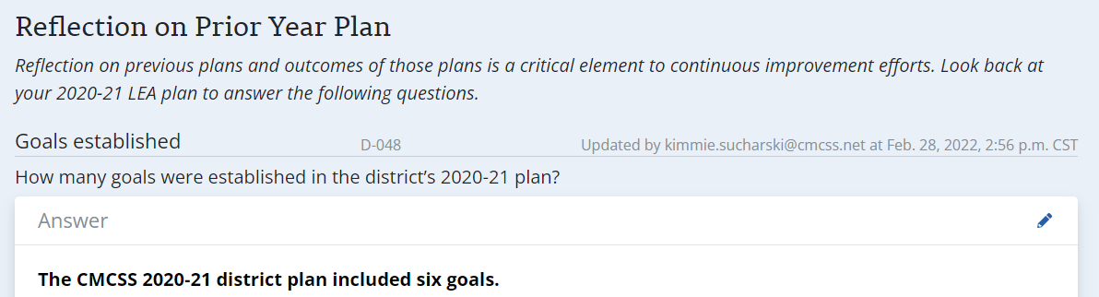  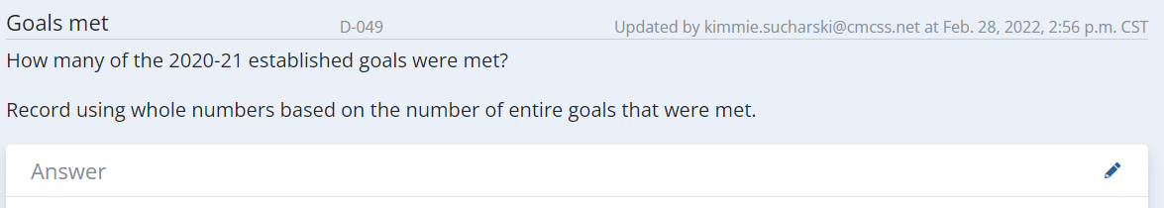  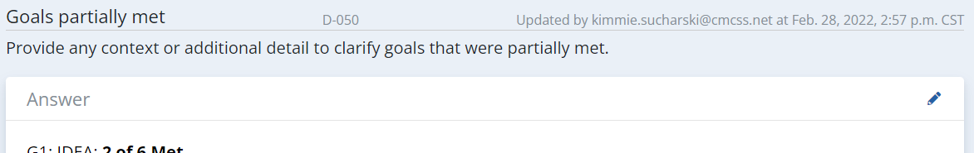
- Open and read the content in ‘Analyze Needs’ | 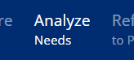
- All Schools:  - Open the ‘Reflect to Plan Tab’  - Do not click on the ‘I Accept’ button under Assurances at this time.  - Add your school specific information to every topic as appropriate.  - The district has completed a lot of the topics but there are still several incomplete topics (especially within Title schools).  - Ensure each Title I category includes all school level information at the bottom of any district entered information especially where Title I funds are used. | 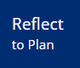  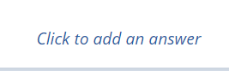
- All Schools:  - Open Upload Documents  - Upload your most current 2022-2023 school plan that was approved by your level director  - If your school receives Title I funds, upload your most currently approved Title budget  - Upload any other supporting documents aligned to your plan. | 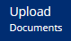  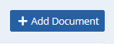
- All Schools:
  - Upload at least one document showing evidence of stakeholder involvement
Example: A sign in sheet and agenda from a meeting where you discussed the budget and plan for the school year.
- IMPORTANT UPDATE FROM 2020-2021:
  - All school Title expenditures must be included in the school’s action steps
    - These amounts must match exactly what is in your budget and must be loaded in Develop Plan under your action steps
    - Each item must be approved for Title spending
    - Each expense must be listed, not in generalized terms
    - All expenses must have evidence-based support with this evidence included in the school plan
      - Some evidence has already been included in the district portions copied into your plans
      - The ‘Non-Regulatory Guidance: Using Evidence to Strengthen Education Investments’ resource may be used to help in determining your evidence
      - As requisitions are submitted, the general notes must connect the purchase request to the school plan.
- All Schools:  - All schools must add the person responsible and the estimated completion date for EVERY action step and update the budgeted amounts needed for each (especially Title I or ESSER funds).  - Click on Develop Plan  - Starting with the first option, click the title to open. (Your first option may vary.)  - Scroll down past the Performance Measures to locate the strategies.  - Click on the title of a strategy to open.  - Scroll down to Action Steps.  - In the right corner of Action Steps, click on the Edit pencil.  - Enter the name of the person responsible and the funding sources.  - Enter the estimated completion date (usually the last day of school).  - All Title I funds from your approved budget must be included (dollar for dollar) within your action steps.  - Click Save.  - Repeat process for every Strategy within each Topic G1-G6. (You may have less than 6.)  - Ensure your plan details evidence for Title I expenditures if they have not already been included.  - Add additional school-level information in each action step that is not already listed.  - Update the completion date as appropriate. | 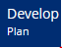  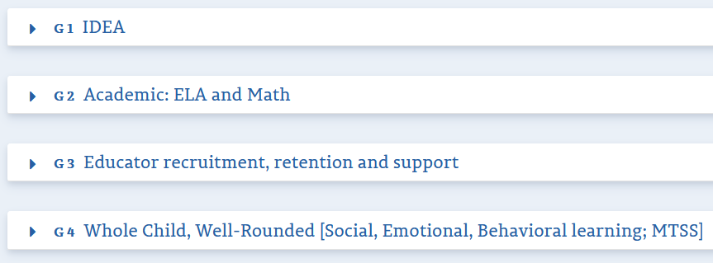  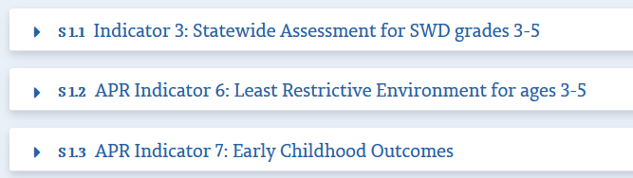  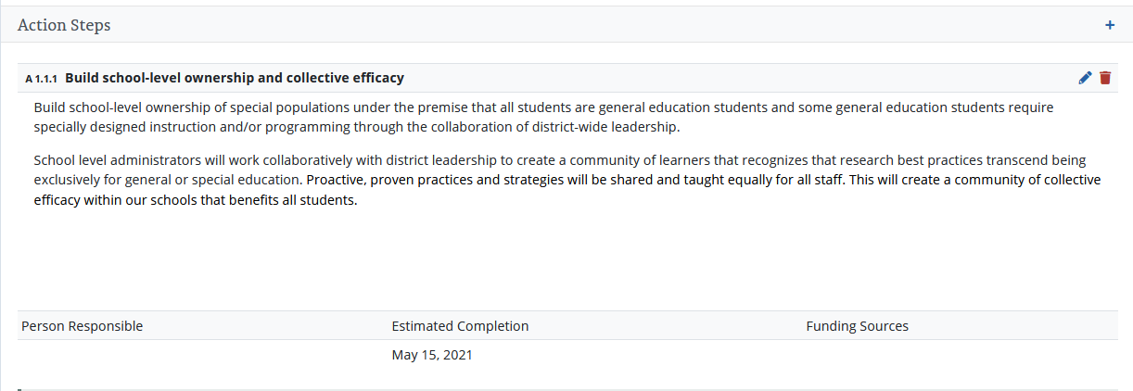  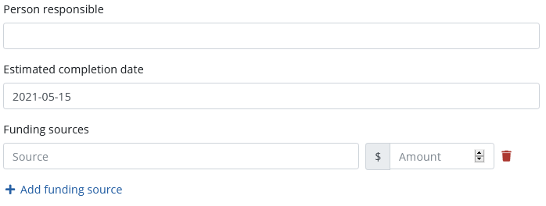
- All ATSI/TSI schools:
  - Ensure you include budgeting for ATSI/TSI (such as MCLs) within your school plans in the same manner as outlined above for Title funds.

- When you believe you have completed the plan,  - Open ‘Review Plan’  - The Review Plan will indicate if any required information is missing – green checkmarks indicate complete.  - Address any incomplete items. | 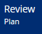  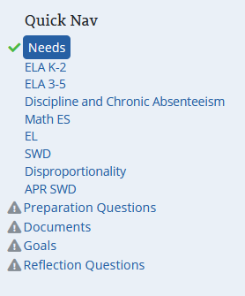
- After you have made all changes listed above and ‘Review Plan’ shows the plan as complete:
  - Email assessment@cmcss.net to let us know you believe you are done.
    - After you plan is reviewed someone from the team will email with items needing additional work or to let you know your plan is ready to submit.
- After you receive and email from someone on the Accountability Team:
  - Open Reflect on Plan and click on the ‘I Accept’ button under Assurances.
  - Email assessment@cmcss.net to let the team know you have completed your school plan
  - The deadline to complete your plan and submit the email is: August 26, 2022

