- Go to https://orion.tneducation.net/launcher and log in.  - Username: first.last@tneducation.net | 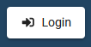  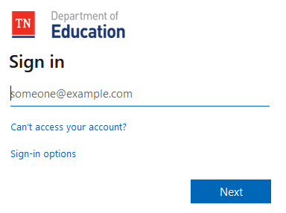
- Select ePlan. | 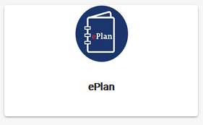
- On the left side, hover over Planning. Then, slide over and select Planning Tool. | 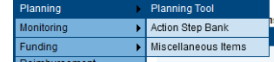
- Select your school. If prompted, click Log In again.
- Open your 2020 School Plan  - Below your school name, you will see the school year listed in the Planning for dropdown.  - The status of your plan is in the top left.  - You will see green check marks next to some tabs showing they are completed. Please note, these are not completed. Most of your plan has been entered but there are still elements you must address. | 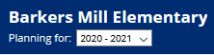  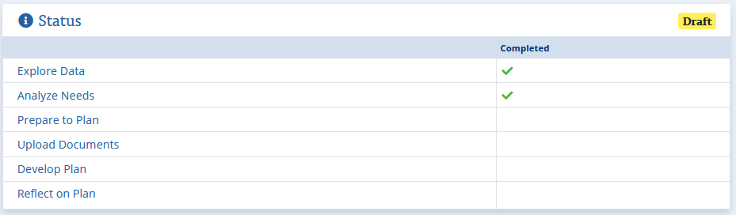
- Open and read the content in all tabs to familiarize yourself with what has already been entered for you.
- All schools:  - Open ‘Prepare to Plan’  - Following the directions complete the ‘Identify Team’ and ‘Stakeholder Involvement’ sections at the top of the page  - You may review your entries for both in last year’s plan as a guide if needed. | 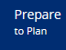  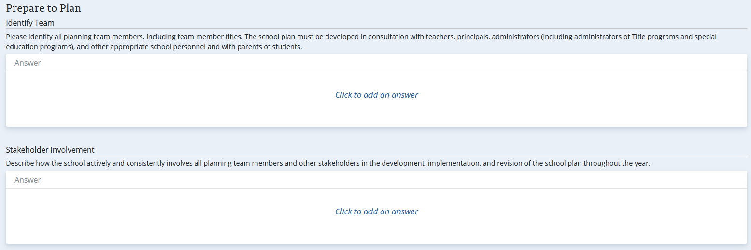
- All Schools:  - Open Upload Documents  - Upload your most current 2020-2021 school plan that was approved by your level director  - If your school receives Title I funds, upload your approved title budget | 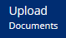  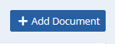
- IMPORTANT UPDATE FOR THIS YEAR
  - All school title expenditures must be included in the school’s action steps
    - These amounts must match exactly what is in your budget
    - Each item must be approved for title spending
    - Each expense must be listed, not in generalized terms
    - All expenses must have evidence-based backing with this evidence included in the school plan
      - Some evidence has already been included in the district portions copied into your plans
      - The ‘Non-Regulatory Guidance: Using Evidence to Strengthen Education Investments’ may be used to help in determining your evidence
      - As requisitions are submitted, the general notes must connect the purchase request to the school plan.
- All Schools:  - All schools must add the person responsible for EVERY action step and update the budgeted amounts needed for each.  - Click on Develop Plan  - Starting with the first option, click the title to open. (Your first option may vary.)  - Scroll down past the Performance Measures to locate the Indicators.  - Click on the title of an Indicator to open.  - Scroll down to Action Steps.  - In the right corner of Action Steps, click on the Edit pencil.  - Enter the name of the person responsible and the funding sources.  - Click Save.  - Repeat process for every Indicator within each Topic G1-G6. (You may have less than 6.) | 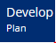  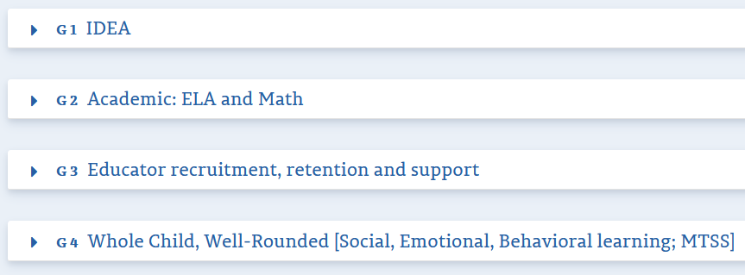  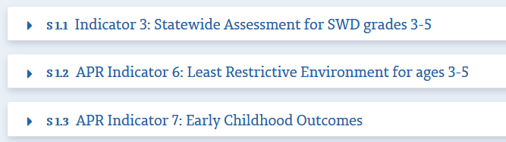  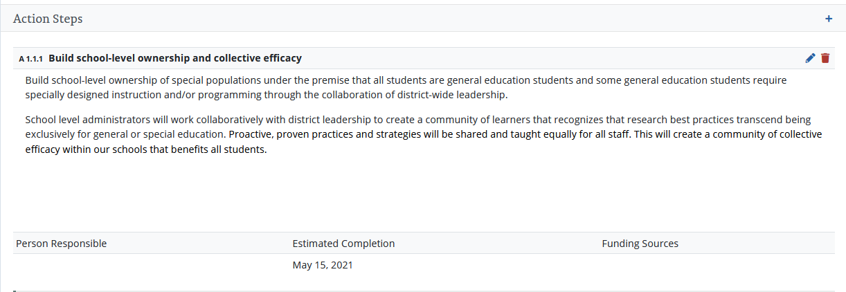  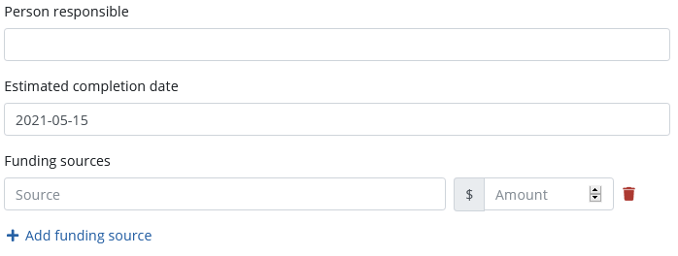
- All Title I Schools:  - Open the ‘Reflect on Plan Tab’  - Add appropriate content to the sections titled: Title I, Strengthen Academics, and Quality Learning | 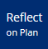  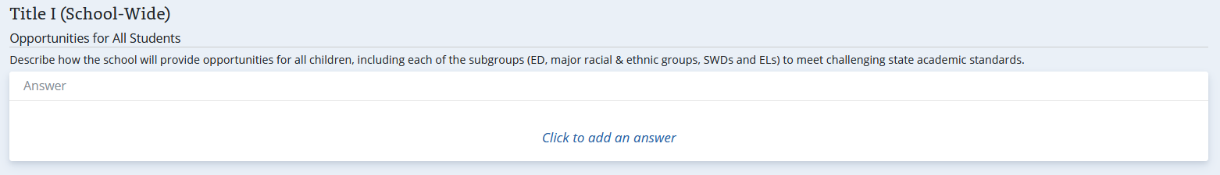  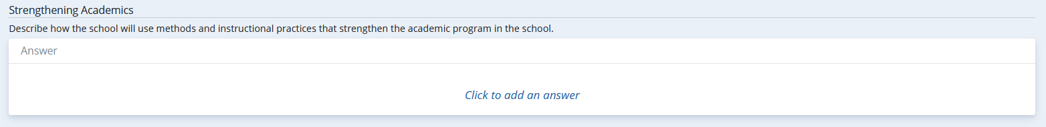  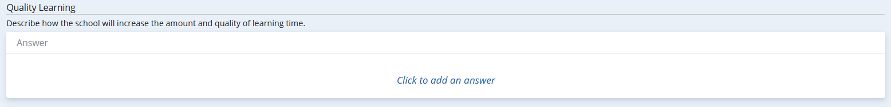
- All 2018 and 2019 ATSI/TSI schools:
  - Ensure you include budgeting for ATSI/TSI (such as MCLs) within your school plans in the same manner as outlined above for title funds.

- When you believe you have completed the plan,  - Open ‘Review Plan’  - The Review Plan will indicate if any required information is missing.  - Address any missing sections. | 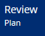  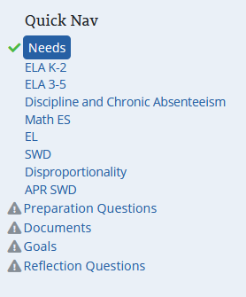
- After you have made all changes listed above and ‘Review Plan’ shows the plan as complete:  - Open Reflect on Plan and click on the ‘I Accept’ button at the bottom of the page  - Email assessment@cmcss.net to let the team know you have completed your school plans  - The deadline to complete your plans and submit the email is: Sep 25, 2020 | 