Press the Windows Key and letter R on your keyboard
Type the following address: \\ic-files.cmcss.net\sharing | 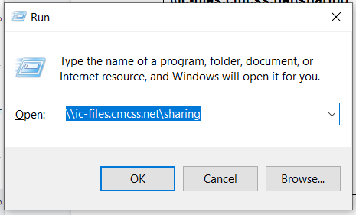
The Sharing Server will open in a window.  To SAVE this link: Click and hold on the folder icon in the address bar with your mouse and drag it to your desktop.  To quickly ACCESS the Sharing Folder in the future:  Double click on the Sharing Folder icon on the desktop to open the folder window. | 